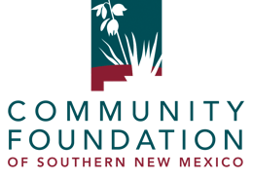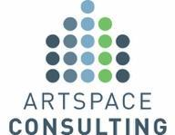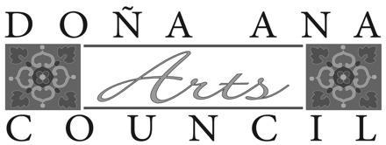
______________________________________________________________________________________

For Immediate Release
June 9, 2022
Contact:

Gregory Z. Smith
director@daarts.org

Terra Winter
terra@cfsnm.org

Tio Aiken
tio.aiken@artspace.org

Community Foundation of Southern New Mexico and Doña Ana Arts Council Partner on Artspace’s Preliminary Feasibility Study

Long a part of plans for the Las Cruces Arts and Cultural District and, more broadly, to help Las Cruces become a serious hub for the arts, artist live/work spaces are one step closer to becoming a reality in New Mexico’s second largest city. Artspace Consulting, a division of Artspace Projects Inc., a nonprofit developer of creative spaces based in Minneapolis, Minnesota, has been engaged by the Community Foundation of Southern New Mexico and Doña Ana Arts Council to study this possibility.

Artspace Consulting will conduct a hybrid Preliminary Feasibility Study and meet with artists, arts organizations, city officials, funders, and other stakeholders. Artspace looks at multiple buildings and sites to start to visualize the project and holds a public meeting to listen to the creative sector on their space needs. There are six areas of consideration during the study: Alignment with Broader Community Goals, Local Leadership, Funding and Finance, Potential Sites, Creative Sector, and Project Concept.

The local partners are setting up a “Las Cruces Core Group” to lead the study. Community members are encouraged to stay tuned for more information on virtual focus groups and how to participate in Artspace Consulting’s in-person visit and public meeting in the coming months. Artspace Projects has fifty-seven artist-centered facilities across the United States, each with its own personality and its own unique connections to where it is located. Their statement about their organization and its work is below:

Artspace is a non-profit organization that uses the tools of real estate development to create affordable, appropriate places where artists can live and work. We consistently develop these projects in ways that also support more stable, healthy communities anchored in existing assets. Because Artspace owns each of the projects it develops, we ensure that they remain affordable and accessible to artists. Over the last three decades, Artspace has led an accelerating national movement of artist-led community transformation. While embracing the value the arts bring to individual lives, Artspace has championed the once-radical idea that individual artists experiencing financial hardship, and chronically underfunded arts organizations can leverage fundamental social change. With headquarters in Minneapolis, and ofﬁces in New York and Washington D.C., Artspace is America’s leading developer of arts facilities and has served as a consultant to hundreds of communities and arts organizations nationwide. Additional information is available at www.artspace.org.

Senior Vice President of Artspace Consulting, Wendy Holmes added, “Artspace is thrilled to begin this feasibility study in Las Cruces after many years of conversations with community members about the critical importance of affordable space to the creative community.”

This important feasibility step was made possible by several, very generous gifts made to the Community Foundation, both directly and on behalf of the Arts Council, with this specific study in mind. CFSNM, under President and Chief Executive Officer, Terra Winter, Ph.D., has been a collaborator for many years and is the co-lead for this study.

“Our Board of Directors, and team, are excited to partner in the first steps to a larger live/work space for artists in our community,” shared Terra Winter. “A matching grant of $7,500 from the USBank Foundation allowed our team to create an opportunity to raise the funds needed to complete the feasibility study. Continual funds will be raised locally and managed by the foundation team while focusing on the sustainability of the project. This is a wonderful opportunity for our nonprofit community to focus on affordable housing while continuing to support the arts in our community.”

Since 2021, DAARTS (DAAC) has also been actively engaged. “The Board of Directors of the Arts Council has been unanimous and enthusiastic in its support for the project,” said Greg Smith, Executive Director of DAARTS. “The fact that it is an included action in the Arts and Cultural District Plan also helps, and we are very grateful to the individuals and entities making major gifts to get this started. It is going to be very good for the arts in our region, and that is going to be very good for our region.”

Smith said that artists and representatives from the City of Las Cruces, Downtown Las Cruces Partnership (including representation for the Arts and Cultural District), Cruces Creatives, the NMSU Art Museum, and other entities will be part of this study. “This needs to be integrated into who we are here and how we harness the arts to benefit our whole community. That’s a giant task, but it is an exciting one to be a part of.”

The Community Foundation of Southern New Mexico serves as a community resource, connects donors to needs, and supports charitable organizations in their work. Please contact President and Chief Executive Officer Terra Winter, Ph.D., at 575.521.4794 or terra@cfsnm.org for more information.

The Arts Council supports and promotes the arts as both part of a thriving creative economy and a source of community pride. DAARTS (DAAC) Board meetings occur on the fourth Thursday of most months. Please contact Executive Director Greg Smith at 575.523.6403 or director@daarts.org for more information.
# # #

